Course Specialist Test 3 Year 12

Student name: ________________ Teacher name: ________________

Task type: Response

Time allowed for this task: ____40_______ mins

Number of questions: _____7______

Materials required: Calculator with CAS capability (to be provided by the student)

Standard items: Pens (blue/black preferred), pencils (including coloured), sharpener, correction fluid/tape, eraser, ruler, highlighters

Special items: Drawing instruments, templates, notes on one unfolded sheet of
A4 paper, and up to three calculators approved for use in the WACE examinations

Marks available: _44_____ marks

Task weighting: _10___%

Formula sheet provided: Yes

Note: All part questions worth more than 2 marks require working to obtain full marks.

Q1 (6 marks)
- Solve the following system of linear equations. (3 marks)

Solution
Specific behaviours
eliminates one variable from two equations
eliminates two variables
solves for all variables

- Determine all possible values of for the three scenarios below. (3 marks)

- No solutions
- One solution
- Infinite solutions

Solution
Specific behaviours
derives equation with two variables eliminated
states values for uniqueness
states values for no solution and infinite (follow through)

Q2 (9 marks)
A particle moves with acceleration at time seconds. The initial velocity is and initial position .
- Determine the velocity at time seconds. (2 marks)

Solution
Specific behaviours
anti-differentiates
solves for constant

- Determine the position vector at time seconds. (2 marks)

Solution
Specific behaviours
determines r
approx. at t=5 (maybe exact or 2 dp)

- Determine on the cartesian path at time seconds. (2 marks)

Solution
Specific behaviours
uses v at t=5
determines rate

- Determine on the cartesian path at time seconds. (3 marks)

Solution
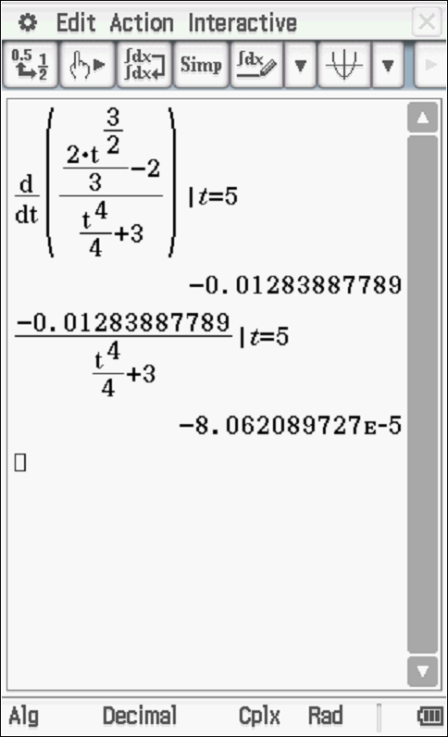
Rate =0.00

Specific behaviours
time diff dy/dx
divides by dx/dt
determines approx. rate (do not penalise if not 2dp)

Q3 (7 marks)
Consider an artificial island that contains a revolving light that is 250 metres from shore. There is a long wall on the shore and the light from the lighthouse can be seen as a moving dot of light on the wall. The angular speed of the light is 24 radians/second, ( ).

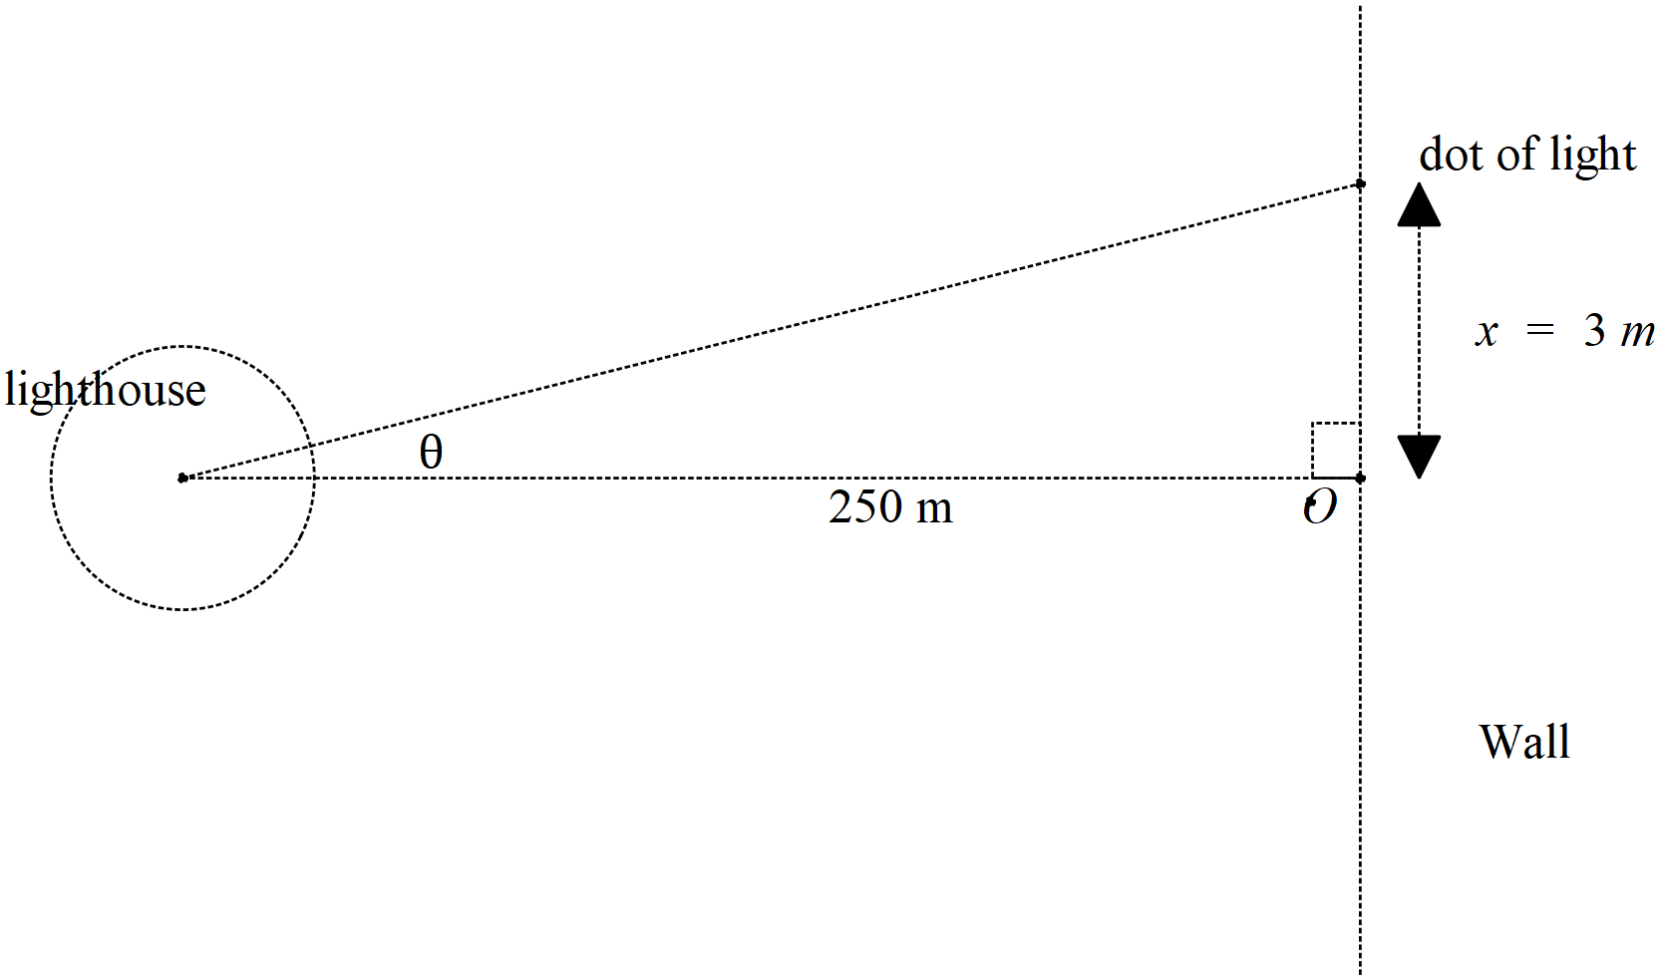
- Determine the speed of the dot of light on the wall when the dot is 3 metres away from the closest point to the lighthouse, pt O, see diagram above. (4 marks)

Solution

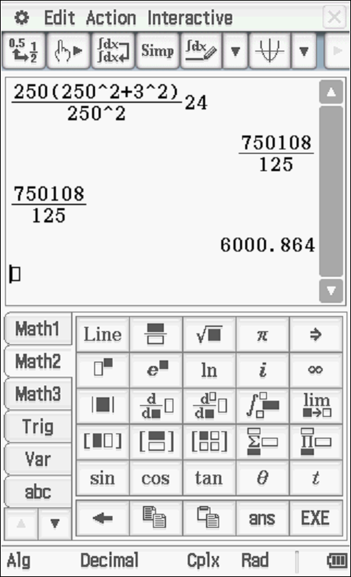

Specific behaviours
states relationship between x and angle
implicit diff wrt time (or related rates(
subs values and uses derivative of angle
determines approx. speed (no need for units)

- If the artificial island containing the lighthouse is moving towards the shore, pt O, at a speed of 5 metres per second, determine the speed of the dot when 3 metres away from pt O and the lighthouse being 170 metres from the shore, pt O. (3 marks)

Solution
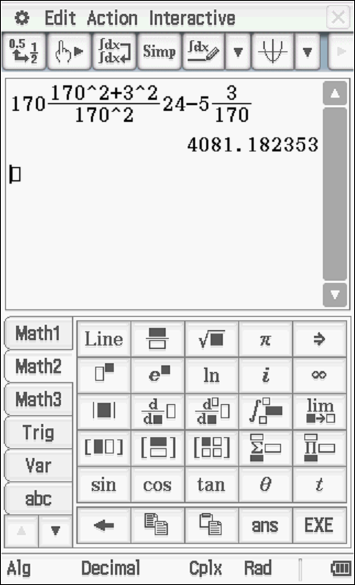

Specific behaviours
uses three variables
uses time implicit with product or quotient and all time rates with correct signs
determines speed

Q4 (3 marks)
Show using logarithmic differentiation how to differentiate .

Solution
Specific behaviours
tales natural log of both sides
implicit diff of both sides and uses product rule
expresses in terms of x&y

Q5 ( 8 marks)
Show how to evaluate the following without any use of the classpad. Show all working.

- (4 marks)

Solution
Specific behaviours
uses Pythagorean identity
breaks into two terms with sinx
anti- diffs both terms
subs both limits to give final result
Q5 cont-
- (4 marks)

Solution
Specific behaviours
uses partial fractions
solves for constants
integrates using logs
states answer with a plus constant

Q6 (7 marks).
Consider a projectile that leaves with speed at an angle to the horizontal, see diagram. Assume that the constant acceleration is .
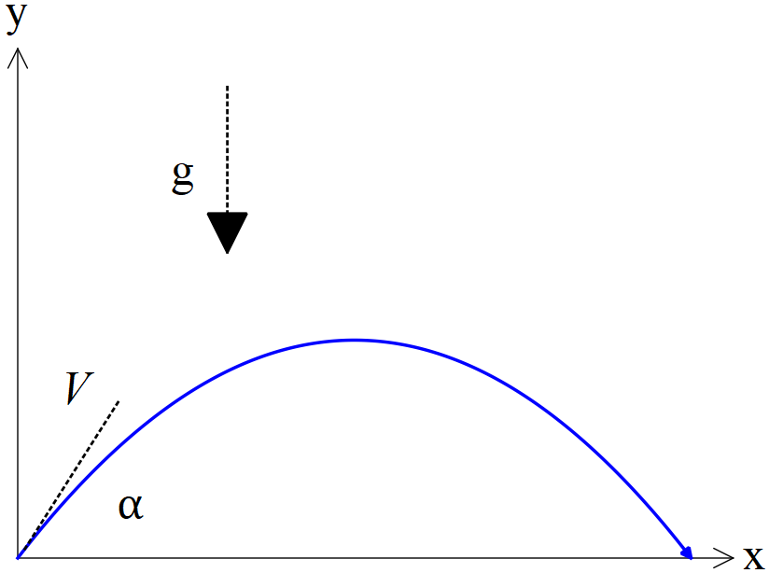

- Using vector calculus and starting with the acceleration, show how to derive the cartesian equation of the path in terms of . (4 marks)

Solution
Specific behaviours
integrates to find velocity and solves for constant
integrates to find r
subs x expression into y by eliminating t
obtains cartesian expression in terms of constants

- Given that and that when , determine possible value(s) for .
(3 marks)

Solution
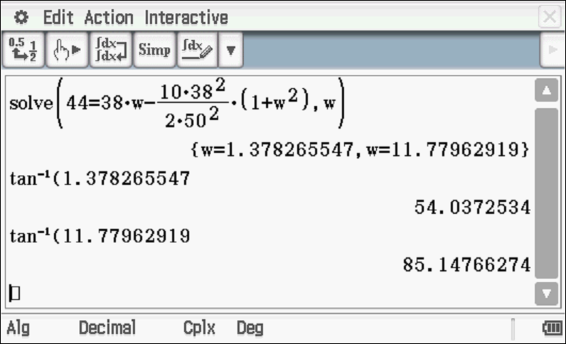

Specific behaviours
subs all knowns into cartesian equation
solves for one angle
solves for two angles

Q7 (4 marks)
Consider the area between , and the x axis with , as shown below.
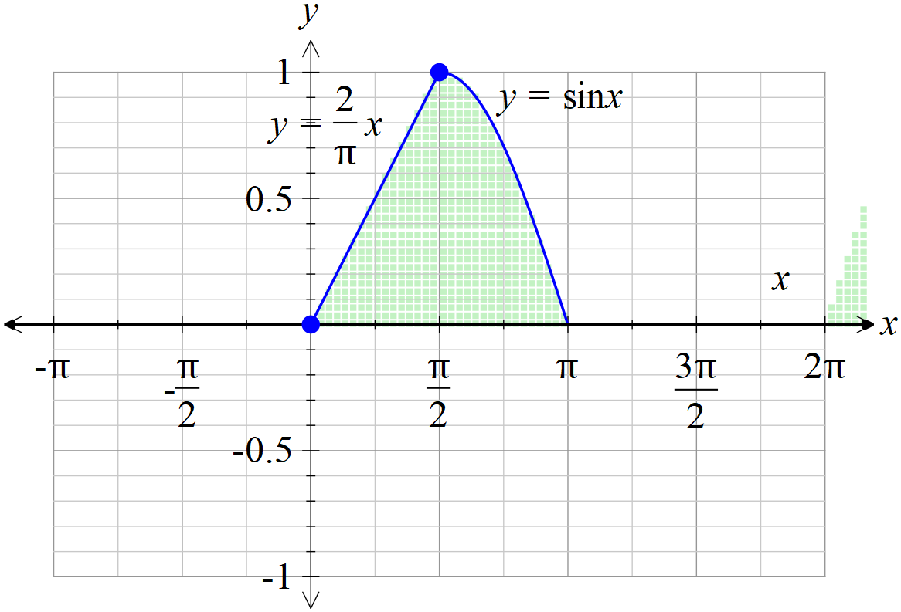

If the shaded area above is revolved around the y axis, determine the volume of the 3D object created.

Solution

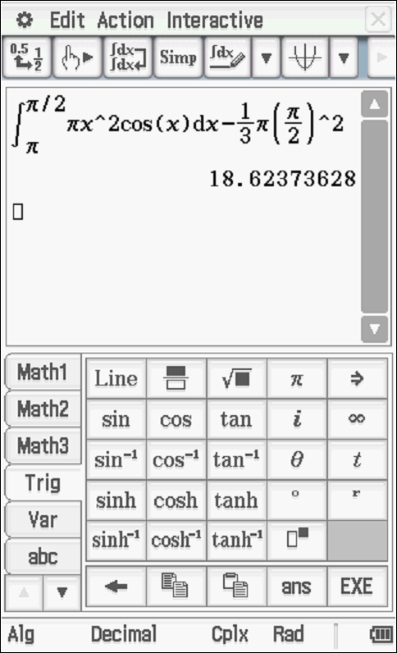

(Note- use of inverse sine function without a translation is incorrect as sine x is a many to one function over 0 to pi domain)
Specific behaviours
uses correct integral with appropriate limits for area under sin x
uses change of variable with correct order of limits
determines volume of cone
obtains correct volume -must be numeric
(no need to round)
(Max 1 out of 4 if revolved around x axis- too easy)
r

